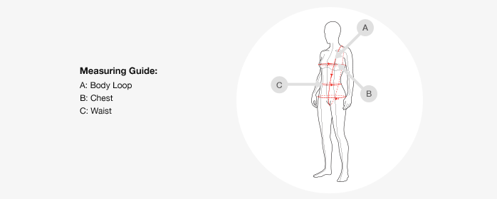
Fastskin LZR Racer® Elite 2 Kneeskin
The following size guide is specifically for the following racing suit:
Fastskin LZR Racer® Elite 2 Kneeskin
Our racing suit sizing is based on three measurements:
Body Loop - place the beginning of the tape measure on the middle of the shoulder. Run the tape measure over the fullest part of your bust down between your legs and up your back to the start point on your shoulder
Chest - Measure over the fullest part of your bust and around your back
Waist - Measure around your navel
Rather than making a selection based on your size in previous racing suits, Speedo recommends that you measure yourself and select the correct size according to the charts below.
It is important that you choose the correct size for the LZR Racer Elite 2 as it may feel more flexible than your size preference in the previous LZR Racer suit. The difference in construction of the LZR Racer Elite 2 represents very slight variants in the fit with, in some instances, the LZR Racer Elite 2 feeling tighter. Swimsuit fit is down to personal preference. Swimmers wishing to achieve a more compressive sensation or tighter fit may find choosing a smaller size is an option.
Speedo Size | Body Loop (cm) | Chest (cm) | Waist (cm)
16 | 128 - 131 | 75 - 76 | 59 - 60
18 | 132 - 135 | 77 - 78 | 61 - 62
20 | 136 - 139 | 79 - 80 | 63 - 64
22 | 140 - 143 | 81 - 84 | 65 - 66
23 | 144 - 152 | 85 - 89 | 67 - 69
24 | 153 - 157 | 90 - 92 | 70 - 71
25 | 158 - 161 | 93 - 95 | 72 - 73
25L* | 158 - 161 | 93 - 95 | 72 - 73
26 | 163 - 166 | 96 - 98 | 74 - 75
26L* | 163 - 166 | 96 - 98 | 74 - 75
27 | 168 - 171 | 99 - 101 | 76 - 77
27L* | 168 - 171 | 99 - 101 | 76 - 77
28 | 173 - 175 | 102 - 104 | 78 - 79
28L* | 173 - 175 | 102 - 104 | 78 - 79
29 | 177 - 180 | 105 - 107 | 80 - 81

